Tardîn
By Lord Andriu mac Domhnaill

This is the original recipe from Annals of the Caliphs' Kitchens, Ibn Sayyār al-Warrāq's Tenth-Century Baghdad Cookbook. English translation by Nawal Nasrallah:
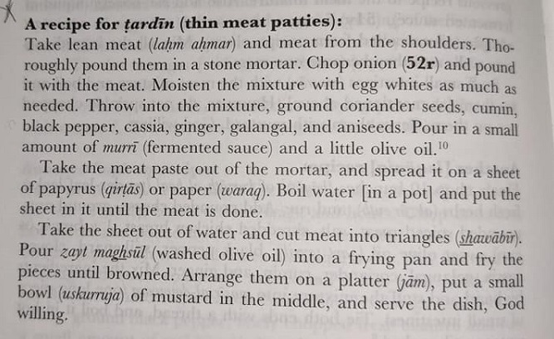

My redaction:
2lbs lean ground meat (in this case beef)
1 small onion diced
Whites if 2-3 large eggs
1 tsp Aniseed
1Tbsp Coriander
1Tbsp Ginger
1Tbsp Galengal
2 tsp Black Pepper
1.5 Tbsp Cummin
1.5 Tbsp Cassia
2Tbsp Olive oil (for the meat)
2 Tbsp Soy Sauce (Murri substitute)
1/2 - 3/4 C Olive oil for frying
Place pot of water on stove and bring water to a boil. Combine all ingredients in a bowl. Spread meat mixture on parchment paper. Flatten until approximately 1/2 inch thick. Fold paper around meat and carefully place in boiling water and let cook for 5-10 minutes. Meat will be firm. Remove from water. Cut into triangles. Heat remaining Olive oil in shallow pan. Carefully add triangles to heated oil and fry until browned. Approximately 1-2 minutes per side. Serve with mustard.

